**Promotional Video Storyboard and Script**

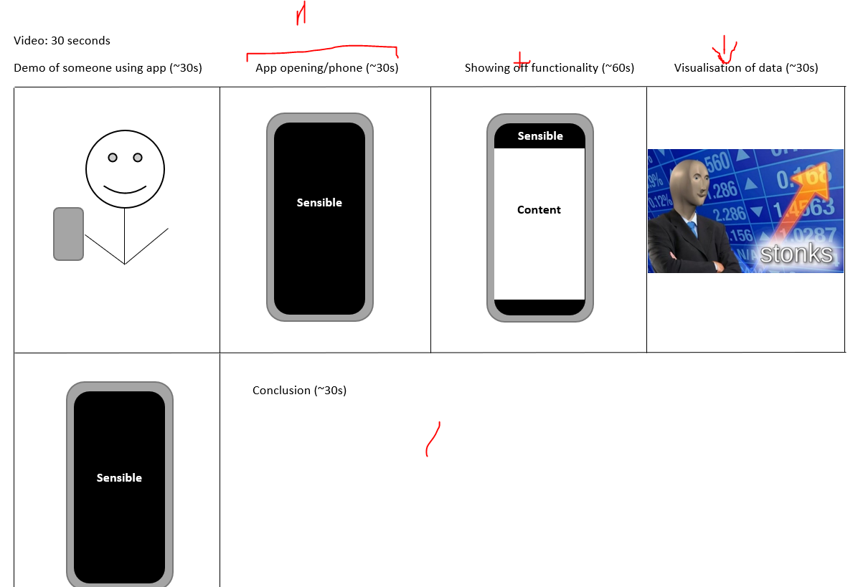

**Discussion**

7 people, should have equal speaking times so ~25s each. I decided not to have visuals of people beyond the first scene, but we can change that by reducing the amount of time that each scene takes and adding that to a new set of scenes where everyone talks.

The first scene should show people using the app to record data. The second should show the opening screen rotating while we present a slightly modified version of the pitch. The third should demonstrate functionality of the app, showing off what you can do and how you can do it. The fourth, we can have a visualisation of the data produced by the app while we talk about how it’s produced. And in the 5th and last, we can have a conclusion where we talk up the benefits of the app and possible improvements in the future.

**Possible script:**

<1st scene> Introduce some confusion as to what the person is doing, then reveal it’s for the app <2nd scene> This is Sensible. Gathering well-labelled data for machine learning projects can be very difficult and expensive. These days we all carry around a mobile phone which has sensors ranging from accelerometers to ambient light sensors. The goal of this project is to produce an app for Android and iOS which can harness these existing sensors for data collection. It will allow data to be labelled in real-time as well as allow selecting which sensors collect the data. The app is for educational purposes and will be very useful for machine learning students as they will not be restricted to using existing applications which tend to either not allow labelling or don't allow the selection of sensors. <3rd scene> Talking through each of the pages, the interactions of each one and how a user would do the recordings <4th scene> Data noises <5th scene> Motivate and stuff “This is sensible. If you want to learn more, email is email and you can talk to our friendly team about finding out more.”